**UJIAN MINGGUAN 4**

**MYSQL**

1. Tampilkan data Name, Region, Population pada tabel Country dan Language berdasarkan Country Population diatas rata-rata.

**Jawaban :**

SELECT country.Name, country.Region, country.Population, countrylanguage.Language FROM country INNER JOIN countrylanguage ON country.Code = countrylanguage.CountryCode

WHERE Population > (SELECT AVG(Population) FROM country);

**Hasil :**

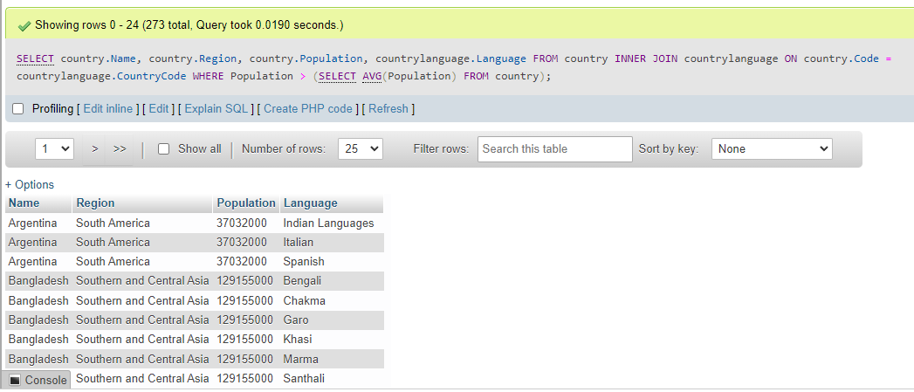

1. Tampilkan data Name, District, Population pada tabel City dan Name Country berdasarkan City Population diatas rata-rata.

**Jawaban :**

SELECT city.Name, city.District, city.Population, country.Name FROM city INNER JOIN country ON city.CountryCode = country.Code WHERE city.Population > (SELECT AVG(Population) FROM city);

**Hasil :**

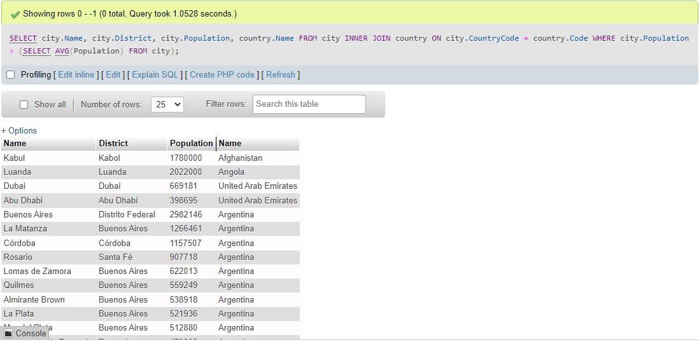

1. Tampilan data Name, Region, Population pada tabel Country berdasarkan IndepYear null.

**Jawaban :**

SELECT Name, Region, Population FROM country WHERE IndepYear IS NULL;

**Hasil :**

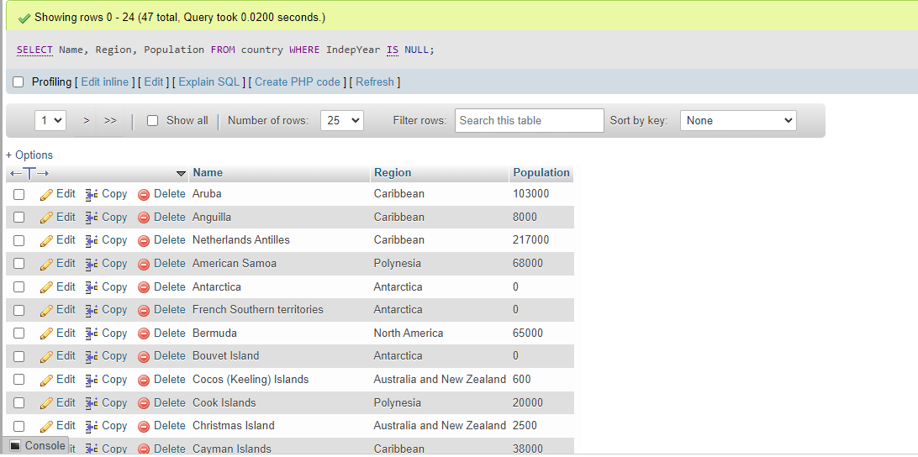

1. Tampilkan data jumlah Country berdasarkan Region yang memiliki Jumlah Country diatas 5.

**Jawaban :**

SELECT COUNT(Region) AS 'Jumlah Country' FROM country GROUP BY Region HAVING COUNT(*) > 5;

**Hasil :**

